Overview -  
Contoso, Ltd. is a consulting company that has a main office in Montreal and two branch offices in Seattle and New York.  
The company hosts its entire server infrastructure in Azure.  
Contoso has two Azure subscriptions named Sub1 and Sub2. Both subscriptions are associated to an Azure Active Directory (Azure AD) tenant named contoso.com.  
  
Existing Environment -  
  
Azure AD -  
Contoso.com contains the users shown in the following table.  
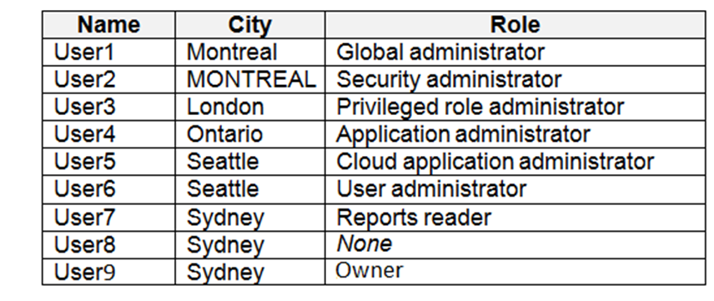  
Contoso.com contains the security groups shown in the following table.  
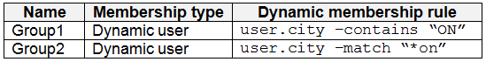  
  
Sub1 -  
Sub1 contains six resource groups named RG1, RG2, RG3, RG4, RG5, and RG6.  
User9 creates the virtual networks shown in the following table.  
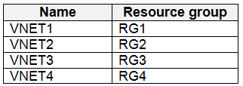  
Sub1 contains the locks shown in the following table.  
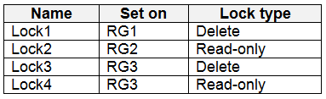  
Sub1 contains the Azure policies shown in the following table.  
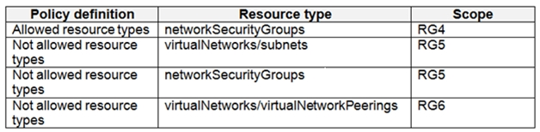  
  
Sub2 -  
Sub2 contains the virtual networks shown in the following table.  
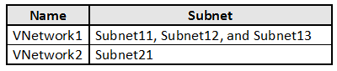  
Sub2 contains the virtual machines shown in the following table.  
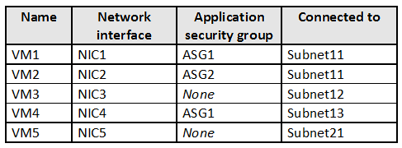  
All virtual machines have public IP addresses and the Web Server (IIS) role installed. The firewalls for each virtual machine allow ping requests and web requests.  
Sub2 contains the network security groups (NSGs) shown in the following table.  
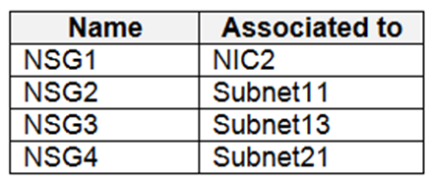  
NSG1 has the inbound security rules shown in the following table.  
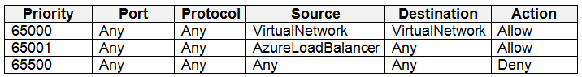  
NSG2 has the inbound security rules shown in the following table.  
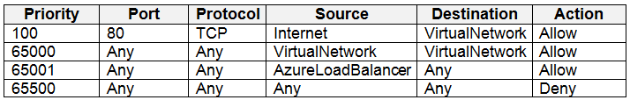  
NSG3 has the inbound security rules shown in the following table.  
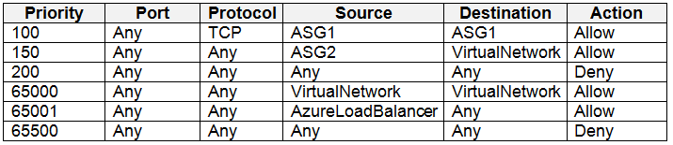  
NSG4 has the inbound security rules shown in the following table.  
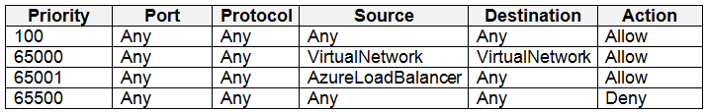  
NSG1, NSG2, NSG3, and NSG4 have the outbound security rules shown in the following table.  
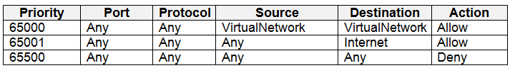  
  
Technical requirements -  
Contoso identifies the following technical requirements:  
Deploy Azure Firewall to VNetwork1 in Sub2.  
Register an application named App2 in contoso.com.  
Whenever possible, use the principle of least privilege.  
Enable Azure AD Privileged Identity Management (PIM) for contoso.com.